HCDCC Candidate Endorsement Information

Candidate Name:
Virginia Bass

Campaign Address:
P.O. Box 6095
Eureka, CA 95502

Residence Address:
2609 U Street
Eureka, CA 95501

Candidate Cell:
707-499-5000

Candidate E-mail:
bass4supervisor@gmail.com

FPPC #:
13228873

Party Affiliation:
Democrat

Occupation:
Humboldt County Supervisor, 4th District

Employer:
County of Humboldt

Proposed Ballot Designation:
Humboldt County Supervisor, 4th District

Elected offices currently/previously held (partial list):
Humboldt County Supervisor, 4th District
Eureka Mayor
Eureka City Council
Humboldt County Democratic Central Committee, 4th District

Other campaigns for elected office:
N/A

Appointed offices currently/previously held (partial list):
- Humboldt County Board of Supervisors, former chairwoman
- Humboldt County’s Local Agency Formation Commission (LAFCO), commissioner and former chair
- Redwood Region Economic Development Commission (RREDC), board of directors
- California State Association of Counties (CSAC), 1st Vice President
- California Restaurant Association, board member
- Humboldt Convention & Visitors Bureau, board member

Other organizations I currently belong to:
Salvation Army, board member
Rotary Club of Eureka
Kiwanis Club of Henderson Center, first female president
Eureka Chamber of Commerce

I also volunteer my time and/or donate to:
American Cancer Society, former board member and chaired Relay for Life for 2 years
Animeals
Boys & Girls Club of the Redwoods
Food for People
Humane Society
Humboldt County Democratic Central Committee
Humboldt County Library
Humboldt Senior Resource Center
League of Women Voters
Planned Parenthood
Sequoia Park Zoo
Toys for Tots
and many, many more

The candidate’s reasons for running for office:
I’m a life-long resident of Eureka. I attended Lafayette Elementary School, Zane Middle School and then graduated from Eureka High School with honors. I then graduated cum laude from Humboldt State University with a Bachelor’s Degree in Business Administration while working full time and raising a family.

After graduating from HSU, I operated my family’s restaurant business, the former OH’s Town House on 6th Street, which was open for more than 50 years. My 30 plus years of working in the restaurant business instilled in me the value of serving others, the importance of taking time to get to know people and the understanding that bringing people together working towards common goals is the best way to achieve real solutions.

In 2000, Eureka City Councilmember Jim Gupton declined to run for reelection to City Council and I was asked to run as someone who could bridge the divide in our town.

In 2010 I ran for County Supervisor as I felt there was a disconnect between the City of Eureka and the County of Humboldt and believe that we are stronger working together.

What the candidate has done for the community:
It’s an honor to represent the residents as your Humboldt County 4th District Supervisor. It’s important that we work together to find collaborative solutions to the problems that affect us all. I couldn’t do what I do without my fellow Board members, our great staff, the City of Eureka and public input. I will continue to address the homeless issues, provide affordable housing for our low-income residents and increase job creation through common-sense reforms that help our local small businesses. Yet at the same time, I want to leverage my experience and knowledge as your County Supervisor and a representative for regional and statewide organizations to bring more solutions, resources and dollars to Humboldt County to protect our environment, support local job creation and increase our supply of affordable housing. We will continue to make inroads with the mental health, addiction and homeless issues. I look forward to continue listening and meeting with residents to hear your concerns.

But that’s just words, let’s look at my actions:
I brought together community partners, such as the City of Eureka, Rotary Club of Eureka, First Church of the Nazarene along with Vern’s Furniture to raise the funds to purchase, deliver and install 27 bunks beds for the Eureka Rescue Mission. Today, 54 homeless folks are now sleeping in beds every night versus mats on the floor.

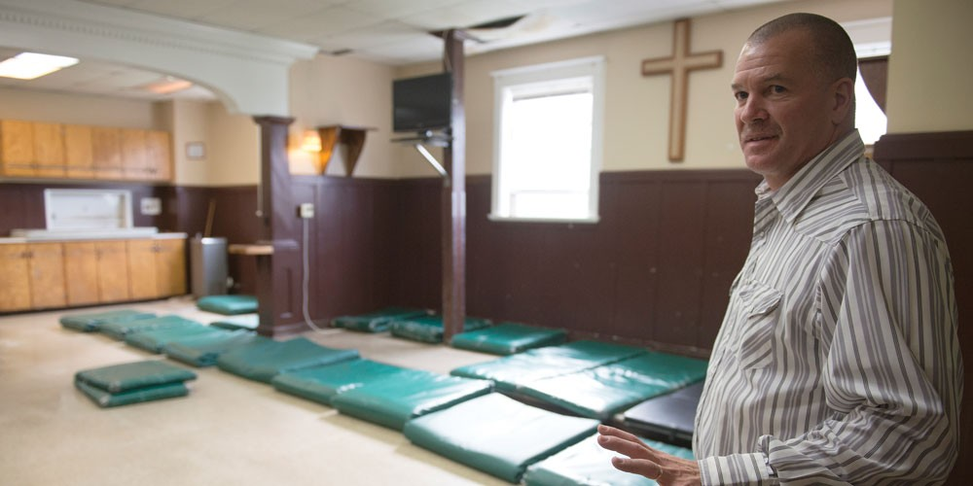

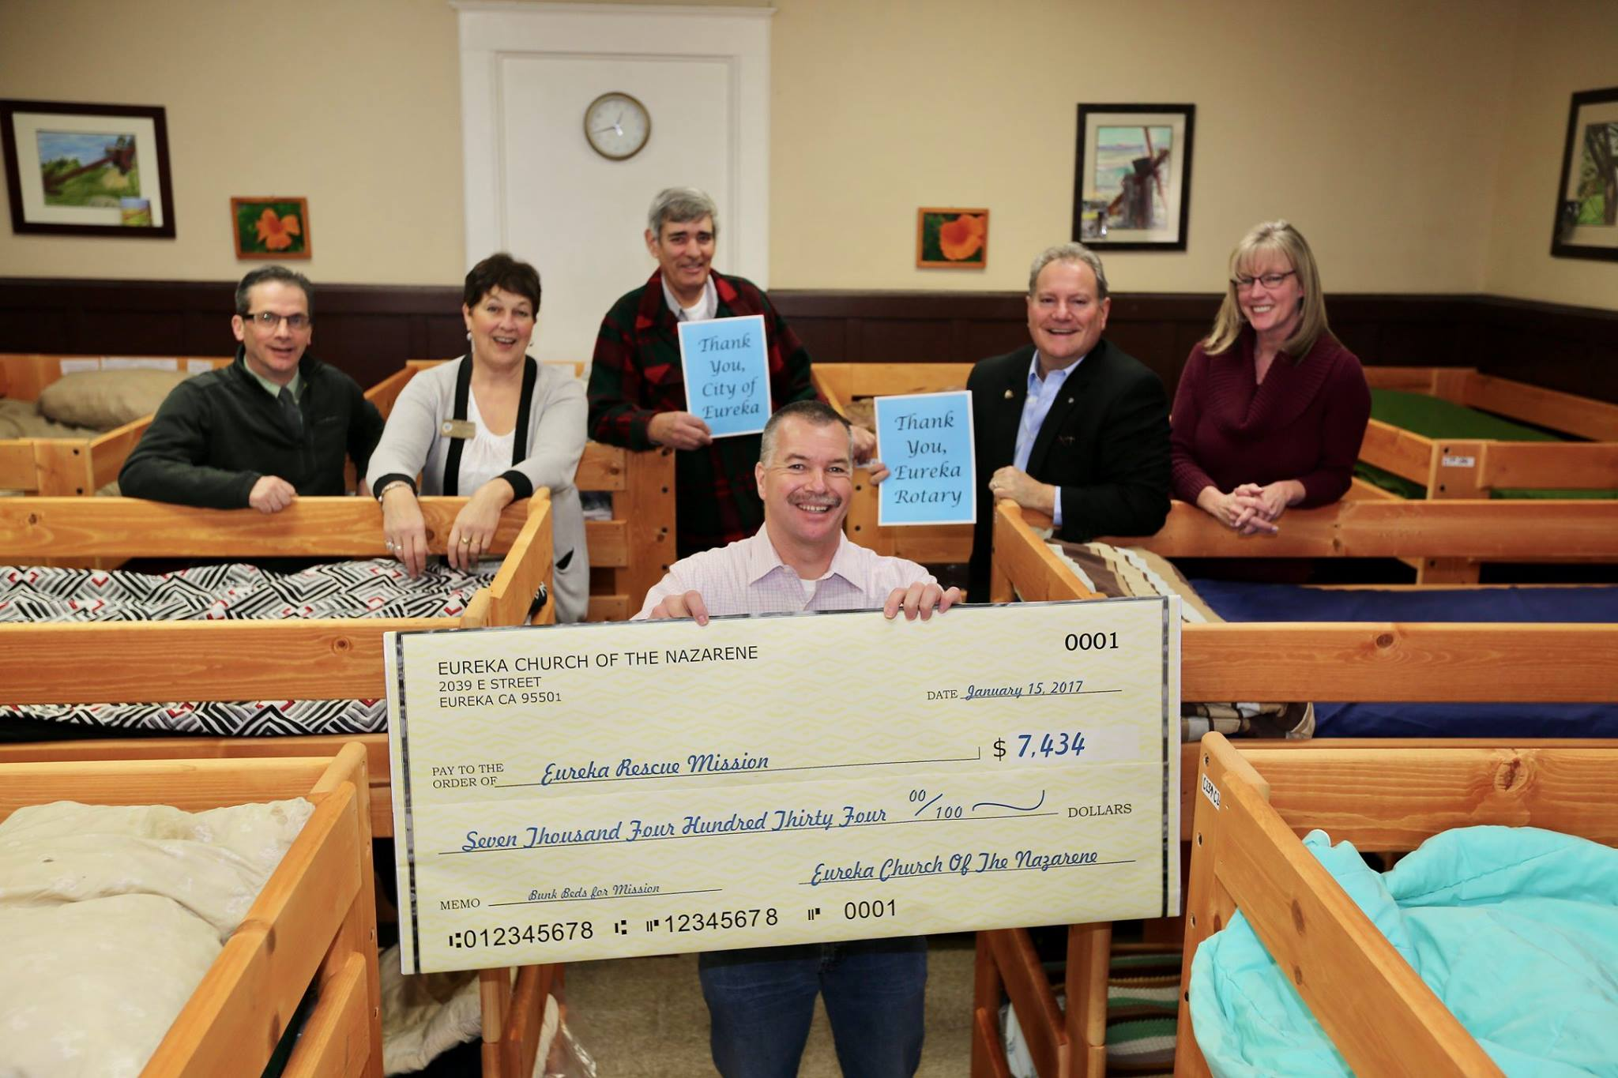

I volunteered two days over a weekend to help assemble 20 bunks beds for Betty Chinn’s new Family Shelter.

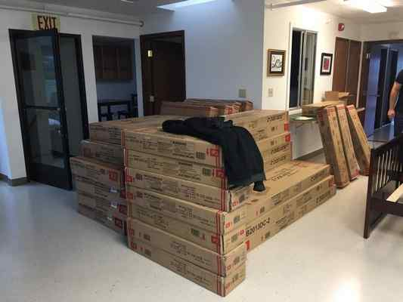

I facilitated the GECOP (Greater Eureka Community Outreach Project), AKA: “Betty’s Blue Angel Village”, which currently houses 40 folks who were formerly homeless in a temporary housing to transition them back into society by working with the City of Eureka and many other community groups and volunteers.

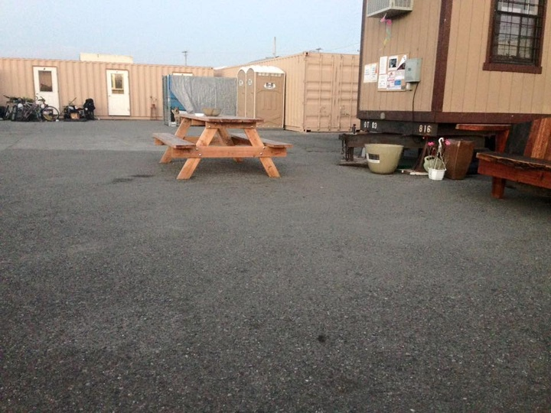

The City and County held their first and only joint meeting to adopt the Focus Strategies document “Housing First”, our plan to house 30 homeless people in 60 days. We actually housed 60 homeless people in the first 60 days.

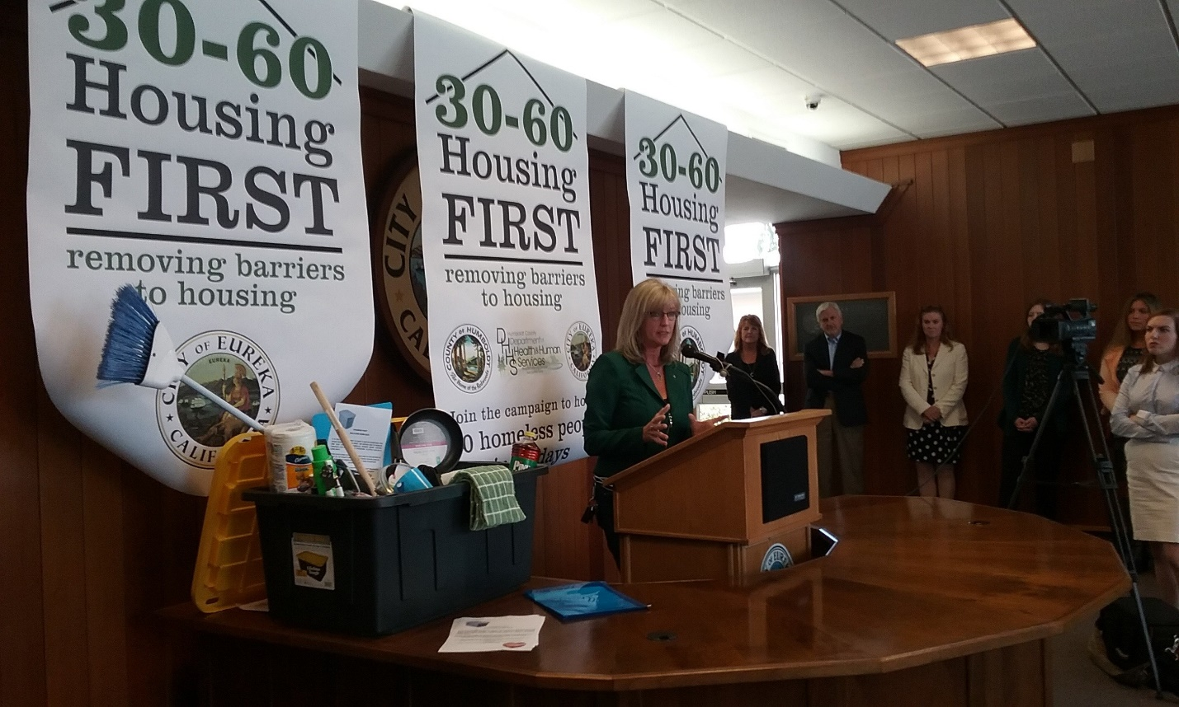

Founding member and donor of the newly created Housing Trust Fund.

Recruited landlords in the community to rent to homeless veterans.

Spearheaded local changes to the HUD Section-8 housing voucher program allowing for some vouchers to “project based”, which can count as matching funds for housing grants.

Partnering with other community groups:
Last year I volunteered with the Rotary Club of Eureka to clean up a blighted drug house in just three hours.

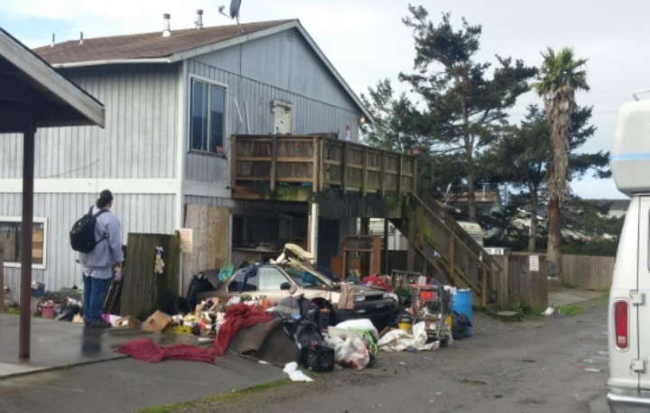

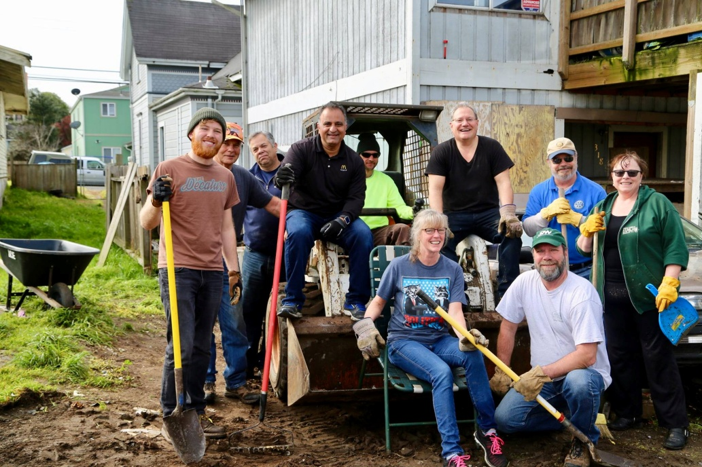

I also regularly volunteer with Pac Out Green Team, Rotary Club of Eureka, Keep Eureka Beautiful, Take Back Eureka and any other local group that’s out doing good cleaning up our community.

I recently co-hosted with State Senator Mike McGuire a standing room only Town Hall on the opioid crisis. We will be doing a follow up Town Hall on this subject on March 29.

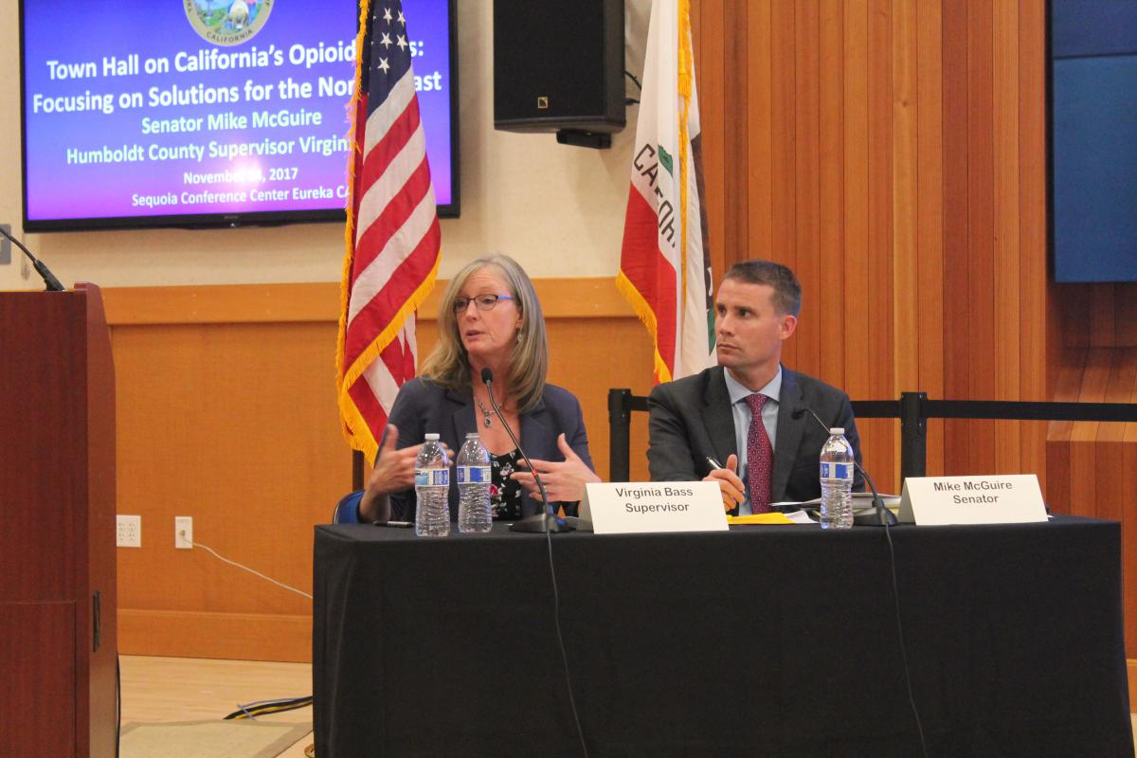

I have been actively involved with Fly Humboldt’s air service recruitment team and organized the funding that raised $80,000 in just two months for the MRG (Minimum Revenue Guarantee) required to obtain new air service routes. I’m proud to announce that as of June 7, we will have daily non-stop flights from ACV to LAX.

While an elected member of the Humboldt County Democratic Central Committee I raised donations and volunteered to do the nitty-gritty work of setting up, cooking my baked beans, serving food, cleaning and putting away the tables and chairs. Baked bean recipe available upon request .

Relevant platforms/issues the candidate supports:
I will continue to address the many of the issues of homelessness. A few years ago I established the Community Homeless Improvement Project (CHIP) in partnership with the County of Humboldt and the City of Eureka, bringing stakeholders together from the non-profit, law enforcement and local government sectors to collaboratively confront the homeless issue. This led to the creation of the Mobile Intervention Services Team (MIST), combining social workers with law enforcement on our streets to address mental illness amongst homeless population and connect those people to the needed services.

I was instrumental in the development of “The Lodge”, which converted a former blighted building in downtown Eureka to an affordable housing project for low-income seniors and homeless.

Working with the Humboldt Bay Harbor District I facilitated job creation and economic development by spearheading efforts to allow underutilized properties zoned for coastal dependent industry (CDI) to be repurposed on an interim basis for other uses along the Samoa peninsula, ensuring the revitalization of those properties and preservation of existing infrastructure.

I’ve been an active partner in the formation of a Community Services District on the peninsula, which is required for an affordable housing project to move forward. This will also improve the environmental conditions on the peninsula.

I supported the continued efforts to establish a regulatory framework for the cannabis industry, including the cultivators and related industries in an effort to encourage them to come into compliance and regulation.

I have spoken on national and state panels across the country on many different issues.

Plans for media coverage and campaign:
My campaign strategy is fairly simple… go through a few pairs of shoe leather walking door-to-door talking to the voters of the 4th District over the next 8o+ days to continue what I’ve been doing since 2015. Since the last election I’ve been going to neighborhoods asking the constituents what they think and what the county can do better to solve their issues, such as pot holes, streets and roads, drug houses, fire hydrants and petty crime.

Most of my media coverage is free media and social media up to the 60 days-out mark, when my campaign consultants decide on how to best implement TV, radio, newspapers, blogs, Internet, mailers, etc.

Current Endorsements List:
I currently have almost 1,000 endorsers. You can view my endorser list on my campaign website: www.bass4supervisor.com
Some of my endorsers are:
State Senator Mike McGuire
Julie Fulkerson, former Humboldt County Supervisor
John Woolley, former Humboldt County Supervisor
Connie Stewart, former Arcata City Councilmember
Mark Wheetley, former Arcata City Councilmember
Sam Pennisi, former Arcata City Councilmember
Mike Downey, former Humboldt County Sheriff
Dale Unea, Fire Chief, Samoa Peninsula Fire District
Bruce Rupp, Humboldt Municipal Water District
Stephen Strawn, former Humboldt County Treasurer

Members of the campaign committee, including campaign manager:
Virginia Bass: candidate
Muelrath Public Affairs: campaign consultants
Matthew Owen: volunteer
And many other community volunteers

Type of financial support available:
I would be honored to receive any support from the Humboldt County Democratic Central Committee, whether it is a monetary contribution, phone banker volunteers, neighborhood canvassing (door-to-door) volunteers, joint mailers, and most importantly – your endorsement.

Thank you for your consideration.

